**Project Development –Delivery of Sprint-3**

|  |  |
| --- | --- |
| Date | 30October 2022 |
| Team ID | PNT2022TMID30411 |
| Project Name | IOT based child safety Gadget monitoring and notification |
| Maximum Marks | 8 Marks |

**Basically, children cannot complain about abusements which they face in their daily life to their**

**Parents. They can’t even realize what actually happens to them at their age. It is also difficult for**

**Parents to identify their children are being abused. Since to prevent children before being attacked, an**

**Autonomous real-time monitoring system is necessary for every child out there. In this system, the**

**Collected values from every sensor like temperature sensor, pulse rate detection sensor, metal detection**

**Sensor, and the location value from GPS are used to detect the status of the child and alerts the**

**Respective guardians using GSM accordingly.**

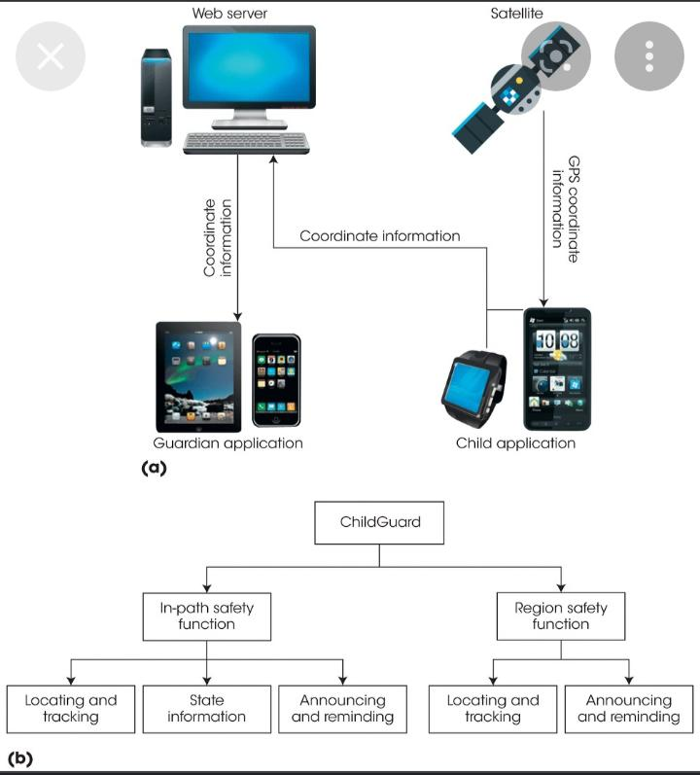

**A portable device which will have a pressure switch. As soon as an assailant is about to attack the**

**Person or when the person senses any insecurity from a stranger, he/she can then put pressure on the**

**Device by squeezing or compressing it. Instantly the pressure sensor senses this pressure and a**

**Conventional SMS, with the victim’s location will be sent to their parents/guardian cell phone numbers**

**Stored in the device while purchasing it, followed by a call. If the call is unanswered for a prolonged**

**Time, a call will be redirected to the police and the same message will be sent. Additionally, if the**

**Person crosses some area which is usually not accessed by the person then a message with the real-time**

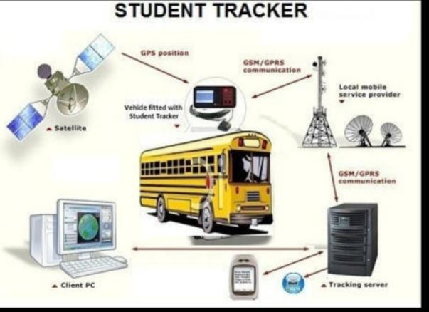

**RFID-based System for School Children Transportation Safety Enhancement**

**This paper presents a system to monitor pick-up/drop-off of school children to enhance the safety of**

**Children during daily transportation from and to school. The system consists of two main units, a bus**

**Unit, and a school unit. The bus unit the system is used to detect when a child boards or leaves the bus.**

**This information is communicated to the school unit that identifies which of the children did not board**

**Or leave the bus and issues an alert message accordingly. The system has a developed web-based**

**Database-driven application that facilities its management and provides useful information about the**

**Children to authorized personnel. A complete prototype of the proposed system was implemented and**

**Tested to validate the system functionality. The results show that the system is promising for daily**

**Transportation safety.**

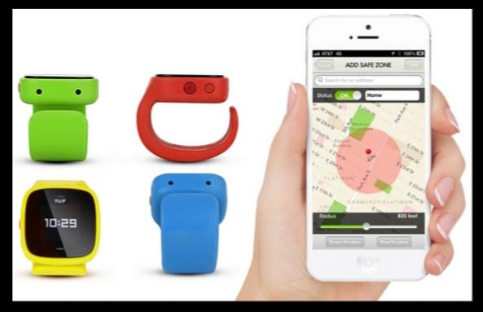

**Parents need not have a smart mobile. Set of keywords are used to gain information from the kit.**

**LOCATION keyword is used to obtain the location of the child. UV keyword is used to obtain the**

**Temperature of the surroundings. BUZZ keyword is used to turn on the buzzer which is fixed in that**

**Device. SOS is used to send a signal to the device.**

**D. Smart Intelligent System for Women and Child Security**

**A portable device which will have a pressure switch. As soon as an assailant is about to attack the**

**# Multiplication table (from 1 to 10) in Python**

**Num = 12**

**# To take input from the user**

**# num = int(input(“Display multiplication table of? “))**

**# Iterate 10 times from I = 1 to 10**

**For I in range(1, 11):**

**Print(num, ‘x’, I, ‘=’, num*i)**

**Output**

**12 x 1 = 12**

**12 x 2 = 24**

**12 x 3 = 36**

**12 x 4 = 48**

**12 x 5 = 60**

**12 x 6 = 72**

**12 x 7 = 84**

**12 x 8 = 96**

**12 x 9 = 108**

**12 x 10 = 120**